

Rozna ulica 20, 6230 Postojna, Slovenia e-mail: [info@rec-bms.com;](mailto:info@rec-bms.com) [www.rec-bms.com](http://www.rec-bms.com/)

BATTERY MANAGEMENT SYSTEM 4 – 15S

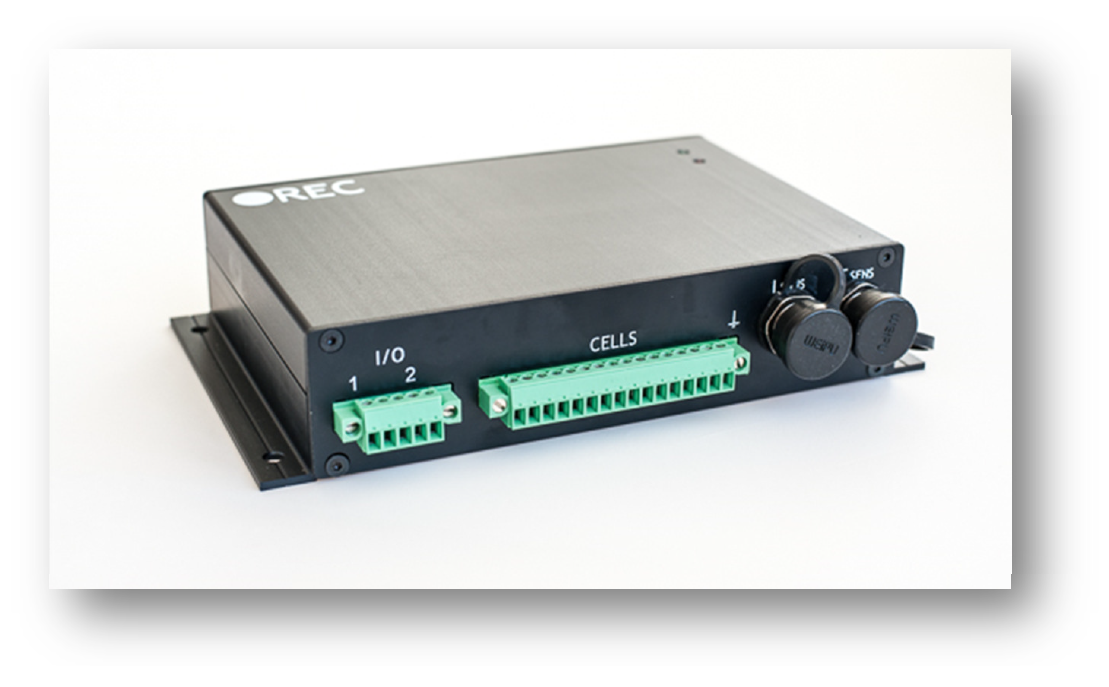

# Features:

* robust and small design
* 4 – 15 cells
* single cell voltage measurement (0.1 – 5.0 V, resolution 1 mV)
* single cell - under/over voltage protection
* single cell internal resistance measurement
* SOC and SOH calculation
* over temperature protection (up to 8 temperature sensors)
* under temperature charging protection
* passive cell balancing up to 1.3 A per cell
* shunt current measurement (resolution 7.8 mA @ ± 200 A)
* galvanically isolated user defined multi-purpose digital input/output
* programmable relay (normally open)
* galvanically isolated RS-485 communication protocol
* CAN communication
* error LED + buzzer indicator (option)
* PC user interface for changing the settings and data-logging (optional accessory)
* hibernate switch
* one-year warranty

# General Description of the BMS Unit:

Battery management system (BMS) is a device that monitors and controls each cell in the battery pack by measuring its parameters. The capacity of the battery pack differs from one cell to another and this increases with number of charging/discharging cycles. The Li-poly batteries are fully charged at typical cell voltage 4.16 - 4.20 V. Due to the different capacity this voltage is not reached at the same time for all cells in the pack. The lower the capacity the sooner this voltage is reached. When charging series connected batteries with single charger, the voltage on some cells might be higher than maximum allowed charging voltage at the end of charging. Overcharging the cell additionally lowers its capacity and number of charging cycles. The BMS equalizes cells’ voltage by diverting some of the charging current from higher voltage cells – passive balancing. The device temperature is measured to protect the circuit from over-heating due to the passive balancing. Battery pack temperature is monitored by Dallas DS18B20 digital temperature sensor/s. Maximum 8 temperature sensors per Slave unit may be used. Current is measured by low-side shunt resistor. Battery pack current, temperature and cell’s voltage determine state of charge (SOC). State of health (SOH) is determined by comparing cell’s current parameters with the parameters of the new battery pack. The BMS default parameters are listed in Table 1.

# Default Parameters:

**Table 1:** Default BMS parameter settings.

|  |  |  |
| --- | --- | --- |
| **parameter** | **value** | **unit** |
| balance start voltage | 3.5 | V |
| balance end voltage | 3.6 | V |
| maximum diverted current per cell | up to 1.3 (3.9 Ohm) | A |
| cell over voltage switch-off | 3.8 | V |
| cell over voltage switch-off hysteresis per cell | 0.015 | V |
| charger end of charge switch-off pack | 3.6 | V |
| charger end of charge switch-off hysteresis | 0.15 | V |
| cell under voltage protection switch-off | 2.2 | V |
| cell under voltage protection alarm | 2.6 | V |
| under voltage protection switch-off hysteresis per cell | 0.03 | V |
| cell under voltage protection switch-off timer | 4 | s |
| cells max difference | 0.2 | V |
| **BMS maximum pack voltage** | **62.5** | **V** |
| BMS over temperature switch-off | 50 | °C |
| BMS over temperature switch-off hysteresis | 5 | °C |
| cell over temperature switch-off | 60 | °C |
| under temperature charging disable | -15 | °C |
| max DC current relay @ 60 V DC | 0.7 | A |
| max AC current relay @ 230 V AC | 2 | A |
| BMS unit stand-by power supply | < 90 | mW |
| max DC current @ optocoupler | 15 | mA |
| max DC voltage@ optocoupler | 62.5 | V |
| BMS unit disable power supply | < 1 | mW |
| Slave unit cell balance fuse rating (SMD) | 2 | A |
| internal relay fuse (Master unit) | 2 slow | A |
| dimensions (w × l × h) | 190 x 114 x 39 | mm |
| weight | 0.650 | kg |
| IP protection | IP32 |  |

# System Overview:

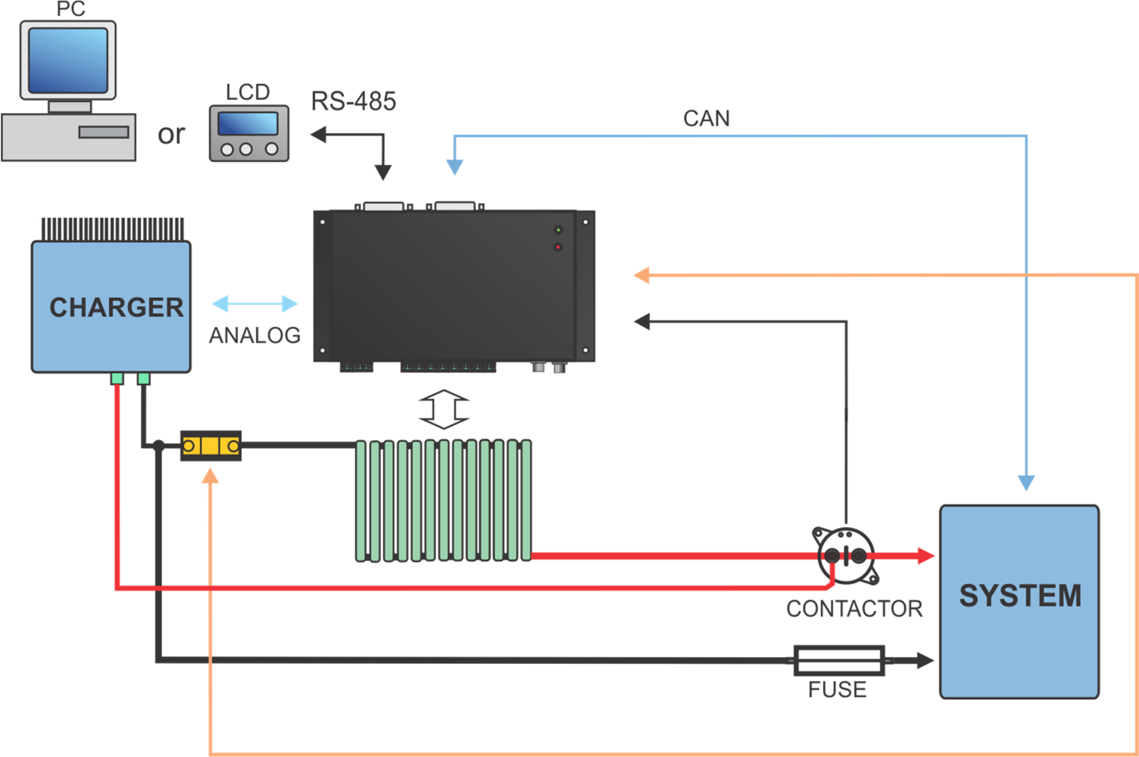

**Figure 1:** System overview.

# BMS Unit Connections:

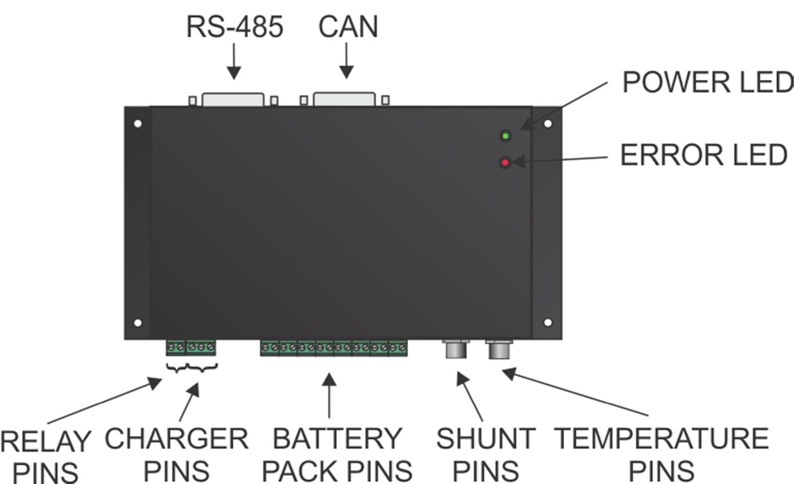

**Figure 2:** BMS unit function overview.

**Table 2:** BMS unit connections.

|  |  |  |
| --- | --- | --- |
| **connection** | **description** |  |
| Temperature  connector | DALLAS 18B20  temp. sensor pins (pin 2) | GND + shield |
| Temperature  connector | DALLAS 18B20  temp. sensor pins (pin 3) | 1-wire digital signal |
| Temperature  connector | DALLAS 18B20  temp. sensor pins (pin 1) | + 5 V |
| Current  connector | + Shunt (pin 3) | Analog signal |
| Current  connector | - Shunt (pin 1 ) | Analog signal |
| Current  connector | Shield (pin 2) | Analog signal |
|  |  |  |
| 7 | Cell 1 ground | Analog signal |
| 8 | Cell 1 positive | Analog signal |
| 9 | Cell 2 positive | Analog signal |
| 10 | Cell 3 positive | Analog signal |
| 11 | Cell 4 positive | Analog signal |
| 12 | Cell 5 positive | Analog signal |
| 13 | Cell 6 positive | Analog signal |
| 14 | Cell 7 positive | Analog signal |
| 15 | Cell 8 positive | Analog signal |
| 16 | Cell 9 positive | Analog signal |
| 17 | Cell 10 positive | Analog signal |
| 18 | Cell 11 positive | Analog signal |
| 19 | Cell 12 positive | Analog signal |
| 20 | Cell 13 positive | Analog signal |
| 21 | Cell 14 positive | Analog signal |
| 22 | Cell 15 positive | Analog signal |
|  |  |  |
| 23 | Charger + 12V | Analog voltage |
| 24 | Charger enable | Analog voltage 0-5V |
| 25 | Charger GND | Analog voltage |
| 26 | Internal Relay | - |
| 27 | Internal Relay | - |

# Setting Number of Cells and the RS-485 Address:

Number of cells connected to the BMS unit is selected via CELL DIP Switch pins at the back of the unit. Binary addressing is used to enable setting up to 15 cells with 4 DIP Switches.

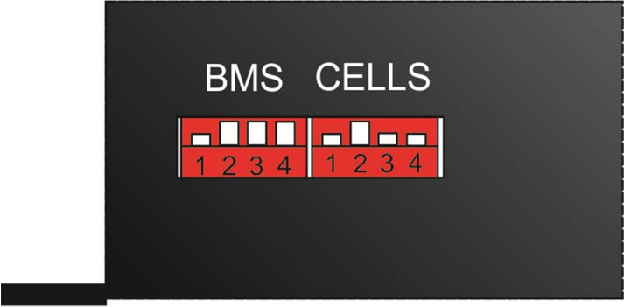

**Figure 3:** Address and cell selection DIP Switches.

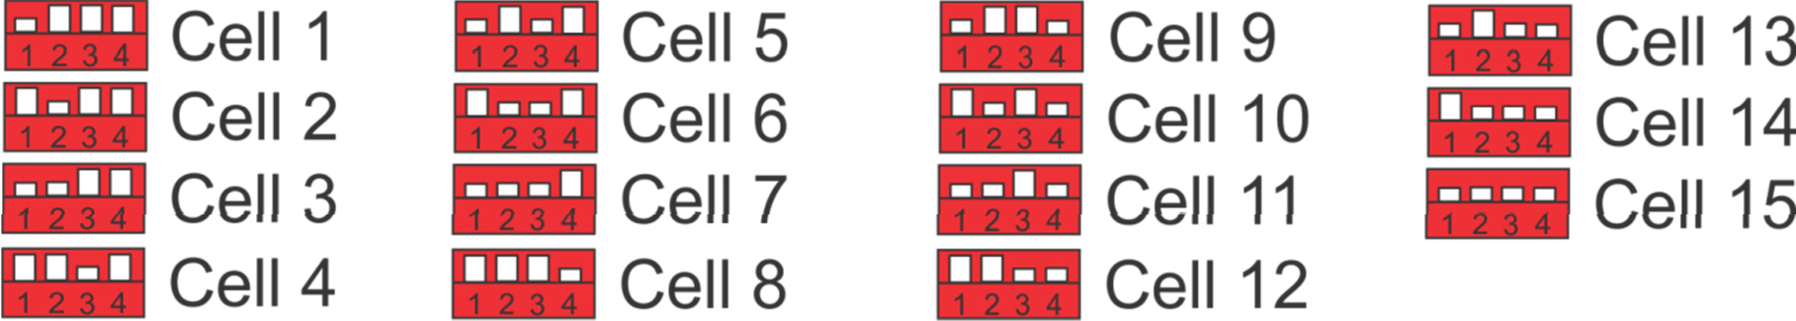

**Figure 4:** Number of cell selection description.

BMS unit address is selected via Address DIP Switch pins (BMS) at the back of the unit. Binary addressing is used to enable setting up to 15 addresses with 4 DIP Switches. **! If multiple BMS units are used distinguished addresses should be set to avoid data collision on the RS-485 communication bus!**

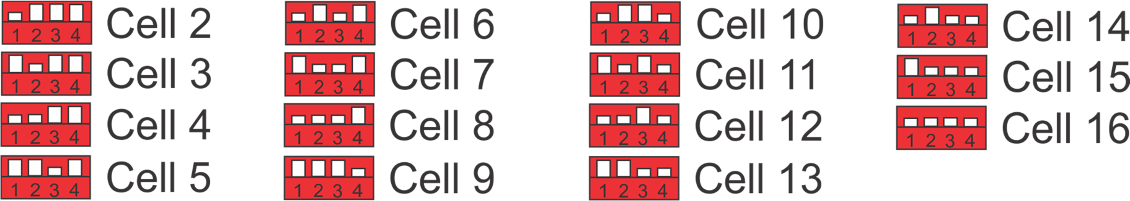

**Figure 5:** BMS unit address selection description.

# BMS Unit Cell Connector:

Connect each cell to the BMS unit cell connector plug. Use silicon wires with cross section of 0.75 - 1 mm2 (25-23 AWG). ! **Before inserting the cell connector check voltages and polarities with voltmeter of each connection!**

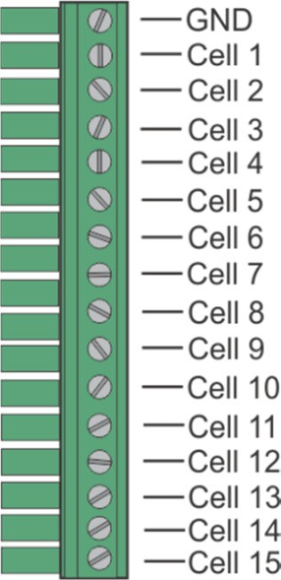

**Figure 6:** Battery pack to BMS connection.

# BMS Unit Power Supply:

BMS unit is always supplied from the 15-th cell connection. **! When less than 15 cells are used in the battery pack, an additional wire with Pack + voltage should be connected to the cell 15 connector !**

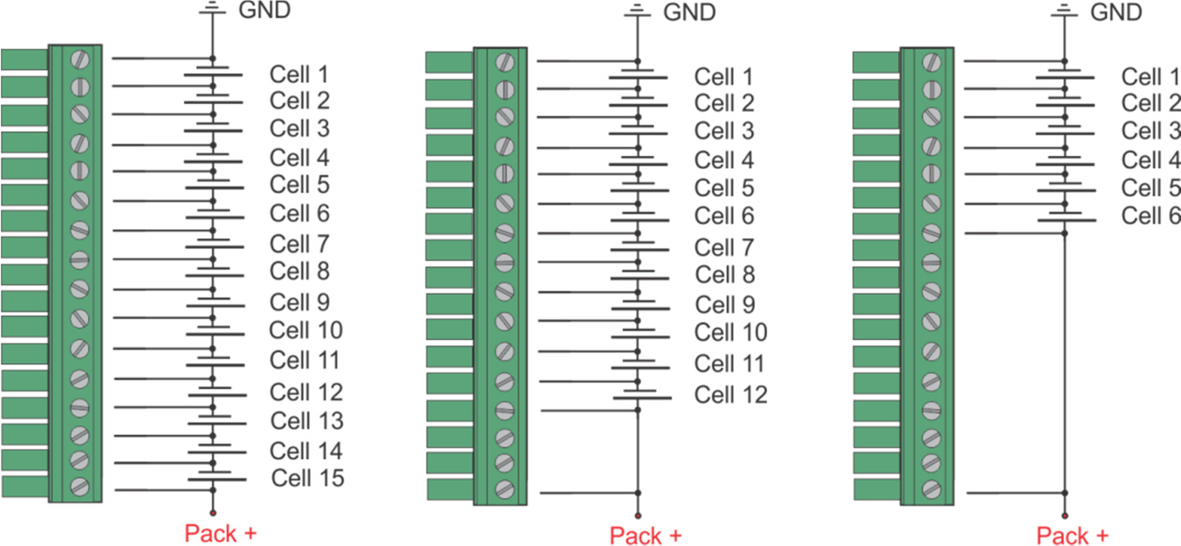

**Figure 7:** BMS unit power supply.

# BMS Unit Connection Instructions:

Connect the BMS unit to the system by the following order described in Fig. 8. It is important to disable all the BMS functions by turning enable switch OFF before plugging any connectors. **All cells should be connected last and simultaneously**. When all the system components are plugged in, the enable switch can be turned ON and the Slave unit starts the test procedure.

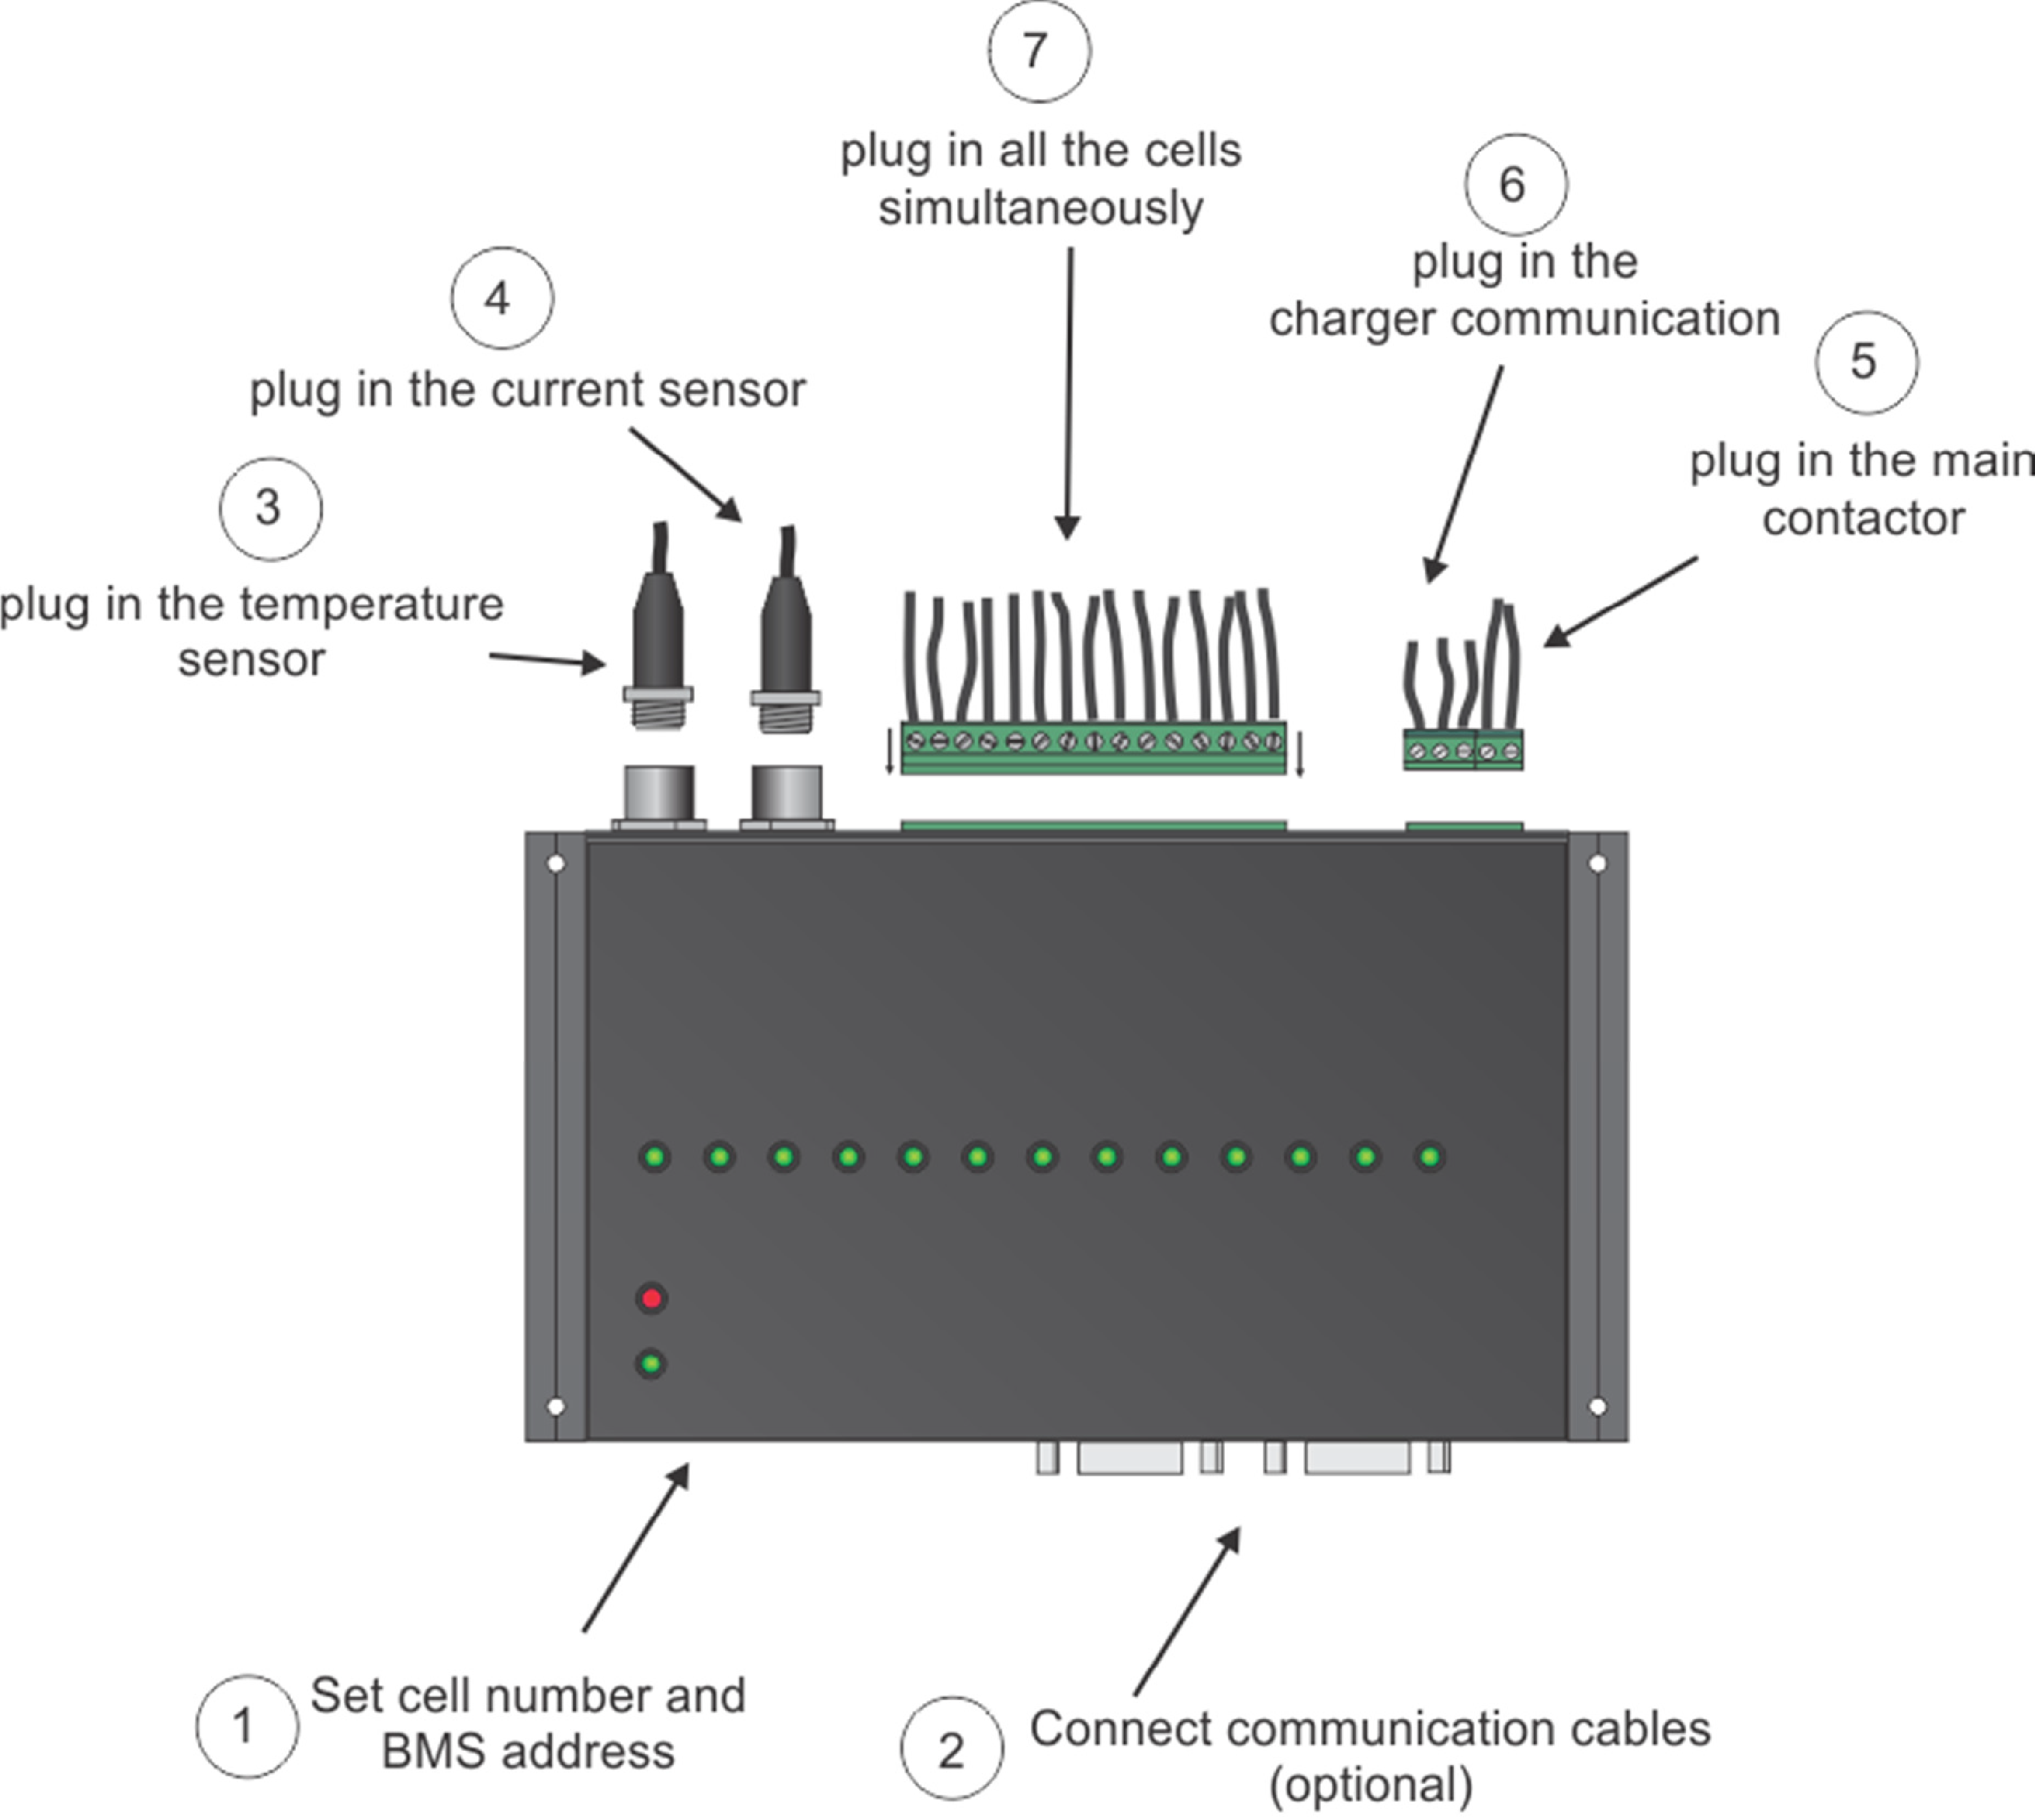

**Figure 8:** BMS connection order.

When disconnecting the unit from the battery pack, the procedure should be followed in reverse order.

# RS-485 Communication Protocol:

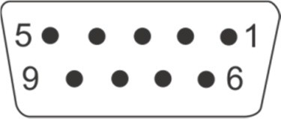

**Figure 7:** RS-485 DB9 connector front view.

**Table 3:** RS-485 DB9 connector pin designator.

|  |  |
| --- | --- |
| **Pin** | **Designator** |
| 1 | - |
| 2 | A |
| 3 | B |
| 4 | GND |
| 5 | - |
| 6 | - |
| 7 | - |
| 8 | - |
| 9 | GND BMS |

BMS unit is programmed as a Slave unit and responds only when asked. Galvanically isolated RS-485 (EN 61558-1, EN 61558-2) serves for logging and changing BMS parameters. Dedicated PC BMS Control Software or another RS- 485 device may be used for the communication.

Messages are comprised as follows:

STX, DA, SA, N, INSTRUCTION- 4 bytes, 16-bit CRC, ETX

* STX start transmition <0x55> (always)
* DA - destination address <0x01> to <0x10> (set as 6)
* SA - sender address <0x00> (always 0)
* N – number of sent bytes
* INSTRUCTION 4 bytes for example.: 'L','C','D','1','?', - (combined from 4 ASCII characters, followed by ‘?’, if we would like to receive the current parameter value or ‘ ’,’xx.xx’ value in case we want to set a new value
* 16-bit CRC, for the whole message except STX in ETX
* ETX - end transmition <0xAA> (always)

Dataflow:

* Bit rate: 56k
* Data bits: 8
* Stop bits: 1
* Parity: None
* Mode: Asynchronous

**Table 4:** RS-485 instruction set.

|  |  |  |
| --- | --- | --- |
| **INSTRUCTION** | **DESCRIPTION** | **BMS ANSWER** |
| '*','I','D','N','?' | Identification | Answer “REC - BATERY  MANAGEMENT SYSTEM” |
| 'L','C','D','1','?' | Main data | Returns 7 float values LCD1 [0] = min cell voltage,  LCD1 [1] = max cell voltage, LCD1 [2] = current,  LCD1 [3] = max temperature, LCD1 [4] = pack voltage,  LCD1 [5] = SOC (state of charge) interval 0-1-> 1=100% and LCD1 [6] = SOH (state of health) interval 0-1-> 1=100% |
| 'C','E','L','L','?' | Cell voltages | BMS first responds with how many BMS units are connected, then it sends the values of the cells in float  format |
| 'P','T','E','M','?' | Cell temperatures | BMS first responds with how many BMS units are connected then it sends the values of the temperature  sensors in float format |
| 'R','I','N','T','?' | Cells internal DC resistance | BMS first responds with how many BMS units are connected then it  sends the values in float format |
| 'B','T','E','M','?' | BMS temperature | BMS first responds with value 1, then it sends the values of the BMS  temperature sensor in float format |
| 'E','R','R','O','?' | Error | Responds with 4 bytes as follows ERRO [0] = 0 – no error, 1 – error ERRO [1] = BMS unit  ERRO [2] = error number (1-13) in ERRO [3] = number of the cell, temp. sensor where the error occurred |
| 'B','V','O','L', '?'/  'B','V','O','L', ' ','xxx' | Cell END balancing | Returns float voltage [V] |
| 'C','M','A','X','?'/  'C','M','A','X',' ','xxx' | Max allowed cell voltage | Returns float voltage [V] |
| 'M','A','X','H', '?'/  'M','A','X','H', ' ','xxx' | Max allowed cell voltage  hysteresis | Returns float voltage [V] |
| 'C','M','I','N', '?'/  'C','M','I','N', ' ','xxx' | Min allowed cell voltage | Returns float voltage [V] |
| 'M','I','N','H', '?'/  'M','I','N','H', ' ','xxx' | Min allowed cell voltage  hysteresis | Returns float voltage [V] |
| 'T','M','A','X', '?'/  'T','M','A','X', ' ','xxx' | Maximum allowed cell  temperature | Returns float temperature [°C] |
| 'T','M','I','N', '?'/  'T','M','I','N', ' ','xxx' | Minimum allowed temperature  for charging | Returns float temperature [°C] |
| 'B','M','I','N', '?'/  'B','M','I','N', ' ','xxx' | Balancing START voltage | Returns float voltage [V] |

Parameter accepted and changed value is responded with 'SET' answer. Example: proper byte message for 'LCD1?' instruction for BMS address 1 is:

|  |  |  |
| --- | --- | --- |
| 'C','H','A','R', '?'/  'C','H','A','R', ' ','xxx' | End of charging voltage per cell | Returns float voltage [V] |
| 'C','H','I','S', '?'/  'C','H','I','S', ' ','xxx' | End of charging voltage  hysteresis per cell | Returns float voltage [V] |
| 'I','O','F','F','?'/  'I','O','F','F',' ','xxx' | Current measurement zero  offset | Returns float current [A] |
| 'T','B','A','L','?'/  'T','B','A','L',' ','xxx' | Max allowed BMS temperature | Returns float temperature [°C] |
| 'B','M','T','H','?'/  'B','M','T','H',' ','xxx' | Max allowed BMS temperature  hysteresis | Returns float temperature [°C] |
| 'V','M','A','X','?'/  'V','M','A','X',' ','xxx' | Number of exceeded values of  CMAX | Returns integer value |
| 'V','M','I','N','?'/  'V','M','I','N',' ','xxx' | Number of exceeded values of  CMIN | Returns integer value |
| 'T','H','I','S','?'/  'T','H','I','S',' ','xxx' | Number of exceeded values of  TMAX | Returns integer value |
| 'C','Y','C','L','?'/  'C','Y','C','L',' ','xxx' | Number of battery pack cycles | Returns integer value |
| 'C','A','P','A','?'/  'C','A','P','A',' ','xxx' | Battery pack capacity | Returns float capacity [Ah] |
| 'I','O','J','A','?'/  'I','O','J','A',' ','xxx' | Voltage to current coefficient | Returns float value |
| 'R','A','Z','L','?'/  'R','A','Z','L',' ','xxx' | Package cell difference | Returns float voltage [V] |
| 'C','H','E','M', '?'/  'C','H','E','M', ' ','xxx' | Li-ion chemistry | Returns unsigned char value |
| 'S','O','C','S','?'/  'S','O','C','S',' ','xxx' | State of charge | Returns float SOC [0-1.0] |
| 'T','W','I','E','?' | I2C communication error | Returns unsigned char value |
| 'T','R','E','L','?'/  'T','R','E','L',' ','xxx' | Timer for min cell < CLOW before under-voltage relay  turns off | Returns unsigned char value (1-200 means 2-400 s) |
| 'C','L','O',’W','?'/  'C','L','O','W',' ','xxx' | Relay under voltage switch off | Returns float voltage [V] |
| 'C','R','E','F','?'/  'C','R','E','F',' ','xxx' | Reference calibration | Returns float voltage [V](4.996 typ.) |
| 'O','D','D','C','?'/  'O','D','D','C',' ','xxx' | Odd cells calibration coefficient | Returns float value (0.00003 typ.) |
| 'E','A','V','C','?'/  'E','A','V','C',' ','xxx' | Even cells calibration coefficient | Returns float value (0.00003 typ.) |
| 'S','O','C','H','?'/  'S','O','C','H',' ','xxx' | Charger SOC hysteresis | Returns float value 0 - 0.99 |

<0x55><0x01><0x00><0x05><0x4C><0x43><0x44><0x31><0x3F><0x01><0xD9><0xAA>

RS-485 message are executed when the microprocessor is not in interrupt routine so a timeout of 350 ms should be set for the answer to arrive. If the timeout occurs the message should be sent again.

# CAN Communication Protocol:

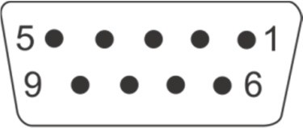

**Figure 10:** CAN DB9 connector front view.

**Table 5:** CAN DB9 connector pin designator.

|  |  |
| --- | --- |
| **Pin** | **Designator** |
| 1 | - |
| 2 | CANL |
| 3 | GND |
| 4 |  |
| 5 | - |
| 6 | GND |
| 7 | CANH |
| 8 | - |
| 9 |  |

Bitrate: 250 kbs

11-bit identifier: 0x031 Default settings TX only

8 byte message structure:

**Table 6:** CAN message structure description.

|  |  |  |  |
| --- | --- | --- | --- |
| **Byte** | **Description** | **Type** |  |
| 1 | State of charge [%] | Unsigned char | 0-200 LSB = 0.5 % SOC |
| 2 | Battery pack voltage high byte | Unsigned integer | 0-65535, LSB = 1 mV |
| 3 | Battery pack voltage low byte |
| 4 | Battery pack current high byte | Signed integer | −32768 to 32767 LSB = 10 mA |
| 5 | Battery pack current low byte |
| 6 | Battery pack temperature | Signed char | -127 to 127 LSB = 1° C |
| 7 | Error number | Unsigned char | 0-13 |
| 8 | Number of the cell or temp.  sensor where the error occurred | Unsigned char | 0-15 |

CAN message is sent every 2 seconds with refreshed values.

# BMS Unit Start Test Procedure:

When the Slave unit is turned ON it commences the test procedure. BMS checks if the user tries to uplod a new firmware by turning on the Power LED. After the timeout Red error LED turns on to signal the system’s test procedure. The procedure starts by testing balancing switches and internal relay. The test completes in 22 seconds, red LED turns off and the BMS unit starts working in normal mode.

# BMS Unit LED Indication:

Power LED (green) is turned on in 2 s intervals, if the BMS is powered. Error LED (red) is turned on in case of system error. Balancing LEDs (green) indicate which cell is balanced.

# BMS Unit Low Voltage Disable:

If the lowest cell’s voltage drops under MIN Vcell ('C','M','I','N') set value (2.6 V per cell default), the BMS signals Error 2. If the lowest cell’s voltage drops further under the relay under-voltage threshold ('C','L','O',’W') for more than set Timer for min cell ('T','R','E','L') internal relay turns off. This feature prevents switching off the system at higher load spikes.

# Cell Voltage Measurement:

Cell voltages are measured every 2 seconds. The cell measurement algorithm performs several measurements to digitally filter the influence of 50, 60, 100 and 120 Hz sinus signal. Each cell voltage is measured after the balancing fuse, in case the fuse blows BMS signals error 10 to notify the user.

# BMS Cell Balancing:

Cells are balanced passively by a 3.9 Ω power resistor. Since the balancing resistors dissipate a lot of heat, there must be an additional temperature measurement inside the enclosure of the BMS unit to prevent overheating the integrated circuits. If the BMS temperature rises above the set threshold, charging and balancing is stopped. BMS error 5 is indicated until the temperature drops under the set hysteresis.

# Balancing START Voltage:

If errors 2, 4, 5, 8, 10, 12 are not present, highest cell voltage rises above Balancing START voltage and current is >

0.2 A (charging stage) the BMS initiates balancing algorithm. A weighted cell voltage average is determined including cells’ DC internal resistance. Balancing algorithm calculates the voltage above which the cells are balanced. The lowest cell voltage is taken into account determining balancing voltage.

# Balancing END Voltage:

If errors 2, 4, 5, 8, 10, 12 are not present, the cells above balancing END voltage are balanced regardless the battery pack current.

# Cell Internal DC Resistance Measurement:

Cell internal DC resistance is measured as a ratio of a voltage change and current change in two sequential measurement cycles. If the absolute current change is above 15 A, cells internal resistance is calculated. Moving average is used to filter out voltage spikes errors. A time interval current-drop is introduced in the battery pack charging current to perform the cell internal DC resistance measurement.

# Battery Pack Temperature Measurement:

Battery pack temperatures are measured by Dallas DS18B20 digital temperature sensors. Up to eight sensors can be used in parallel. BMS should be turned off before adding additional sensors. If the temperature sensors wiring is placed near the power lines a shielded cables should be used.

# BMS Current Measurement:

A low-side shunt resistor current measurement is used. A 4-wire Kelvin connection is used to measure the voltage drop. As short as possible **shielded cable** should be used to connect the power shunt and BMS. The battery pack current is measured every second. A high precision ADC is used to filter out the current spikes. The first current measurement is timed at the beginning of the cell measurement procedure for a proper internal DC resistance calculation. Shunt connection is shown in Fig. 11.

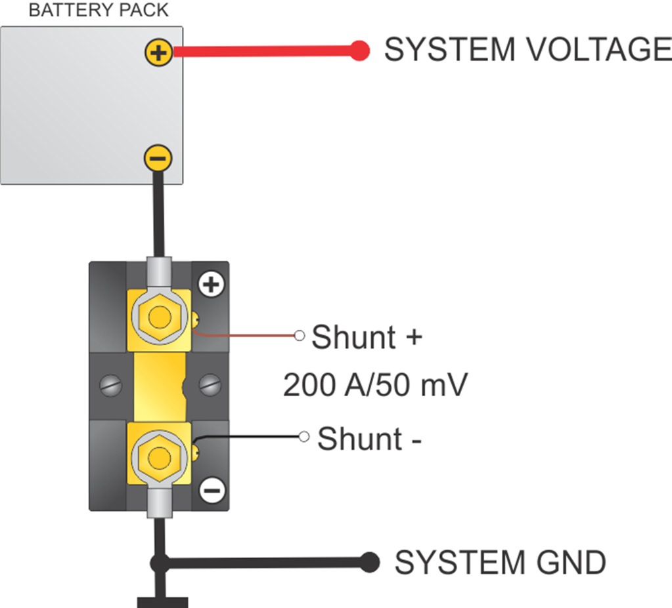

**Figure 11:** Shunt resistor connection.

**Table 7:** Shunt resistor connection.

|  |  |
| --- | --- |
| **Pin** | **Signal** |
| 1 | - Shunt |
| 2 | Shield |
| 3 | + Shunt |

# Voltage-to-current Coefficient:

Different size and resistance shunts can be used, since the voltage-to-current coefficient can be changed in the BMS Control software as 'I','O','J','A',' ','xxxxx'

Current is calculated by the voltage drop at the shunt resistor. 1 LSB of the 18 bit ADC represents different current values according to the shunt resistance. The LSB coefficient can be calculated as:

*k*  0.01171875  0.05 *V*  *V*dropx ,

LSB

300 *A I*

currentx

where the *V*dropx represents the voltage drop on different shunt resistor at current *I*currentx.

**ADC has a pre-set gain of 8. With a maximum input voltage difference of 0.256 V.**

# Battery Pack SOC Determination:

SOC is determined by integrating the charge in-to or out of the battery pack. Different Li-ion chemistries may be selected:

**Table 8:** Li-ion chemistry designators.

|  |  |
| --- | --- |
| **Number** | **Type** |
| 1 | Li-Po High power |
| 2 | Li-Po High capacity |
| 3 | Winston/Thunder-Sky/GWL |
| 4 | A123 |

Temperature and power correction coefficient are taken into consideration at the SOC calculation. Li-Po chemistry algorithms have an additional voltage to SOC regulation loop inside the algorithm. Actual cell capacity is recalculated by the number of the charging cycles as pointed out in the manufacturer’s datasheet.

When BMS is reconnected to the battery pack, SOC is set to 50 %. SOC is reset to 100 % at the end of charging. It can be set to desired value by RS-485 communication protocol by 'S','O','C','S',' ','x.xx' instruction (0.0-1.0).

# System Error Indication:

System errors are indicated with red error LED by the number of ON blinks, followed by a longer OFF state.

**Table 9:** BMS error states.

|  |  |  |  |
| --- | --- | --- | --- |
| **Number of ON blinks** | **ERROR** | **BMS** | **OWNER** |
| 1 | Single or multiple cell voltage is too high (cell over voltage switch-off). | BMS will try to balance down the problematic cell/cells to safe voltage level (20 s error hysteresis + single cell voltage hysteresis is applied).  Internal relay is opened, charger is disabled. | * Wait until the BMS does its job. |
| 2 | Single or multiple cell voltage is too low (cell under voltage protection switch-off). | BMS will try to charge the battery (20 s error hysteresis +single cell voltage hysteresis is applied).  Internal relay is opened to disable discharging (if cell’s voltage is below CLOW for more than TREL), charger is enabled. | * Plug in the charger. |
| 3 | Cell voltages differs more than set. | BMS will try to balance the cells  (20 s error hysteresis + 20 mV voltage difference hysteresis).  Internal relay is closed, charger is enabled. | * Wait until the BMS does its job. If the BMS is not able to balance the difference in a few hours, contact the service. |
| 4 | Cell temperature is too high (over temperature switch-off). | Cells temperature or cell inter- connecting cable temperature in the battery pack is/are too high. (20 s error hysteresis 2°C hysteresis).  Internal relay is opened, charger is disabled. | * Wait until the pack cools down. |
| 5 | BMS temperature is too high (BMS over temperature switch-off). | Due to extensive cell balancing the BMS temperature rose over upper limit (20 s error hysteresis + 5 °C temperature hysteresis).  Internal relay is closed, charger is disabled. | * Wait until the BMS cools down. |
| 6 | Number of cells, address is not set properly. | Number of cells at the back of the BMS unit was changed from the default manufacturer settings.  Internal relay is opened, charger is disabled. | * Set the proper number of cells, address. |

|  |  |  |  |
| --- | --- | --- | --- |
| 7 | The temperature is too low for charging (under temperature charging disable). | If cells are charged at temperatures lower than operating temperature range, cells are aging much faster than they normally would, so charging is disabled (2 °C temperature hysteresis).  Internal relay is opened, charger is disabled. | * Wait until the battery’s temperature rises to usable range. |
| 8 | Temperature sensor error. | Temperature sensor is un-plugged or not working properly (20 s error hysteresis).  Internal relay is opened, charger is disabled. | * Turn-off BMS unit and try to re- plug the temp. sensor. If the BMS still signals error 8, contact the service. The temperature sensors should be replaced. |
| 9 | Communication error. (RS-485 Master-Slave comm. only). |  |  |
| 10 | Cell in short circuit or  BMS measurement error. | Single or multiple cell voltage is close to zero or out of range, indicating a blown fuse, short circuit or measuring failure(20 s error hysteresis + 10 mV voltage difference hysteresis).  Internal relay is opened, charger is disabled. | * Turn-off the BMS and check the cells connection to the BMS and fuses. Restart the BMS. * If the same error starts to signal again contact the service. |
| 11 | Main relay is in short circuit. | If the main relay should be opened and current is not zero or positive, the BMS signals error 11. When the error is detected, the BMS tries to un- shorten the main relay by turning it ON and OFF for three times.  Internal relay is opened, charger is enabled. | * Restart the BMS unit. If the same error starts to signal again contact the service. |
| 12 | Error measuring current. | Current sensor is disconnected or not working properly.  Internal relay is opened, charger is disabled. | * Turn-off the BMS and check the sensor connections, re-plug the current sensor connector. Turn BMS back ON. If the BMS still signals error 12, contact the service. |
| 13 | Wrong cell chemistry selected. | In some application the chemistry pre- set is compulsory. | * Use PC Control Software to set proper cell chemistry. |

# BMS Unit Dimensions:

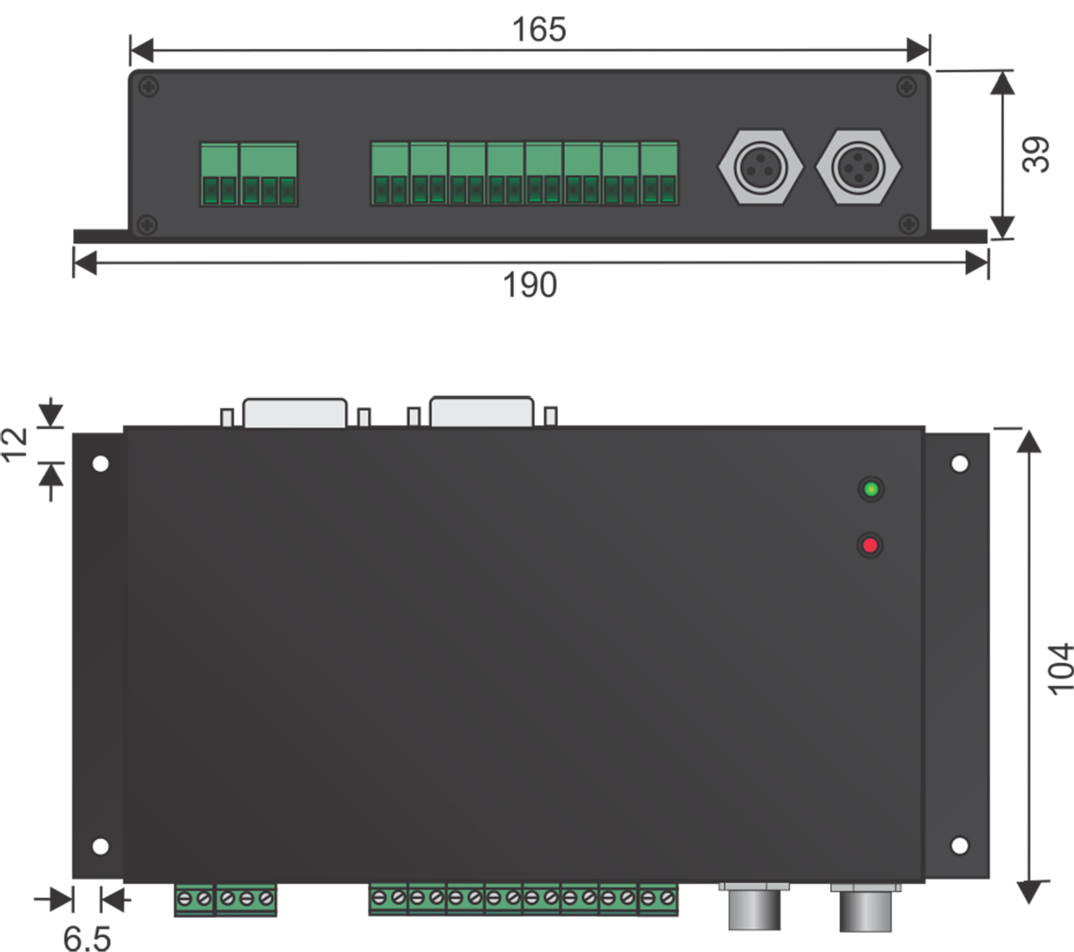

**Figure 12:** BMS unit dimension.

BMS unit can be supplied without the enclosure if an application is weight or space limited. The dimensions of the BMS without the enclosure are 160 mm x 100 mm x 27 mm. A sufficient contact surface for balancing resistors should be provided. The PCB has four 3.2 mm mounting holes. The enclosure is made of black anodized aluminum.